**8.3**

**K-Nearest Neighbor (KNN)**

If it walks like a duck and quacks like a duck, then it's probably a duck.

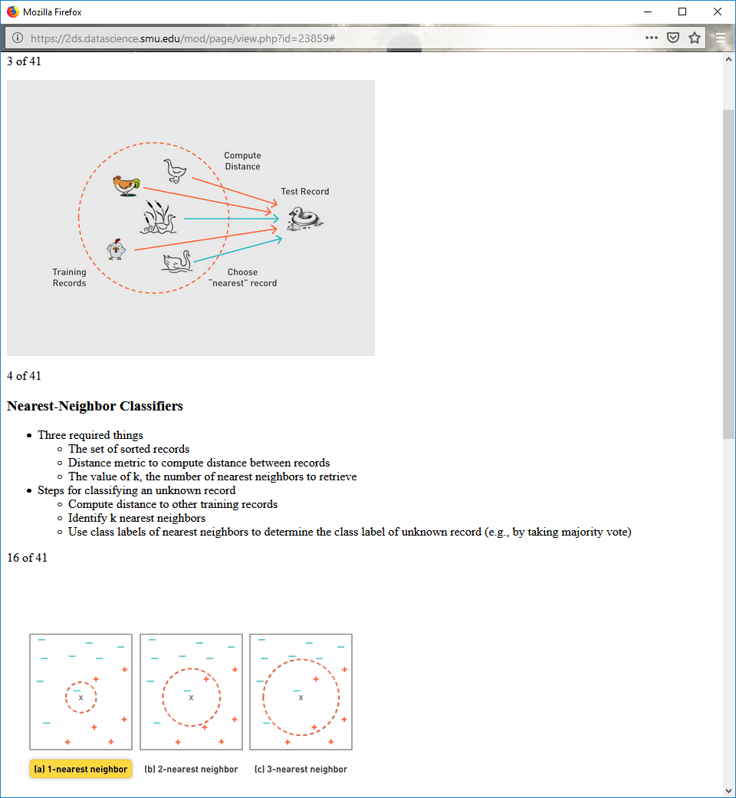

**Nearest-Neighbor Classifiers**

Three required things

The set of sorted records

Distance metric to compute distance between records

The value of k, the number of nearest neighbors to retrieve

Steps for classifying an unknown record

Compute distance to other training records

Identify k nearest neighbors

Use class labels of nearest neighbors to determine the class label of unknown record (e.g., by taking majority vote)



K-nearest neighbors of a record x are data point that have the k smallest distance to x

**Nearest Neighbor Classification**

Compute distance between two points.

Euclidean distance

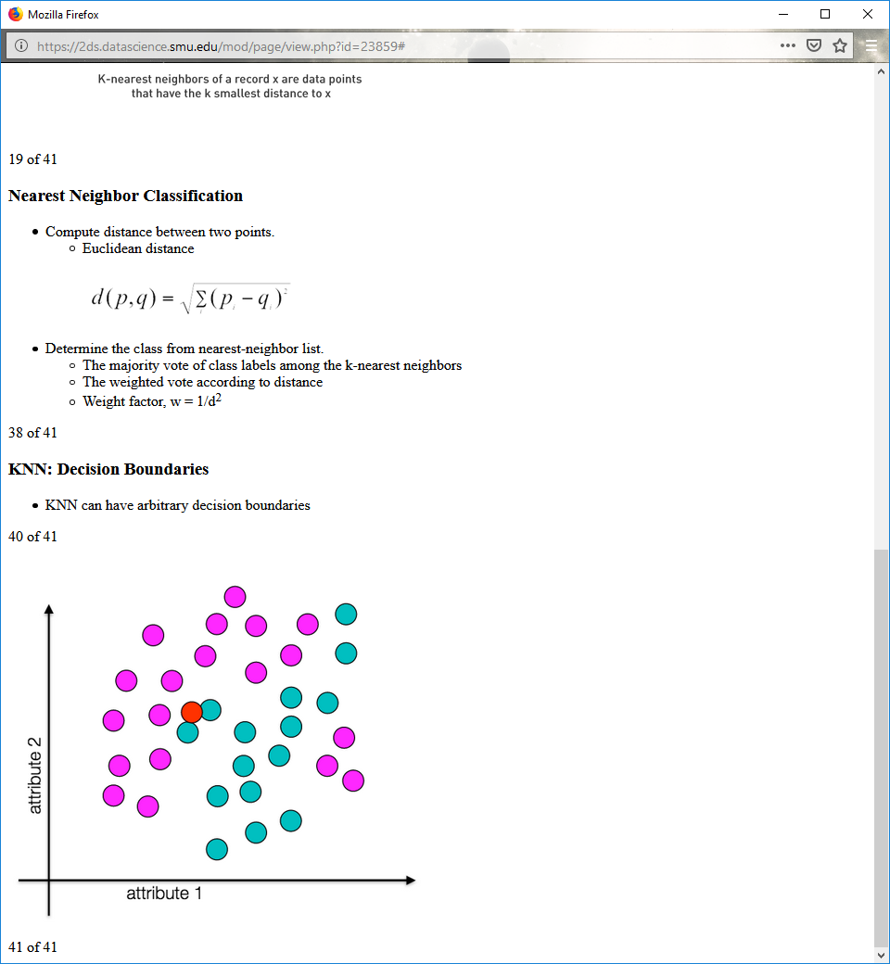

Determine the class from nearest-neighbor list.

The majority vote of class labels among the k-nearest neighbors

The weighted vote according to distance

Weight factor, w = 1/d2

**KNN: Decision Boundaries**

KNN can have arbitrary decision boundaries



**Choosing the Value of K**

If k too small, sensitive to noise points

If k too large, neighborhood may include points from other classes

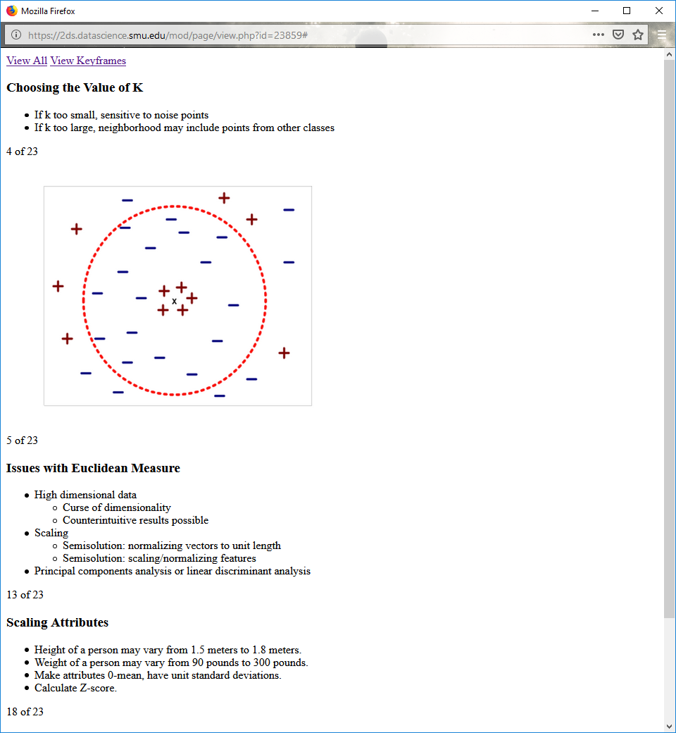

**Issues with Euclidean Measure**

High dimensional data

Curse of dimensionality

Counterintuitive results possible

Scaling

Semisolution: normalizing vectors to unit length

Semisolution: scaling/normalizing features

Principal components analysis or linear discriminant analysis

**Scaling Attributes**

Height of a person may vary from 1.5 meters to 1.8 meters.

Weight of a person may vary from 90 pounds to 300 pounds.

Make attributes 0-mean, have unit standard deviations.

Calculate Z-score.

**Nearest Neighbor Classification**

KNN classifiers are "lazy" learners.

In pure form, model has no parameters.

This is unlike decision tree induction and rule-based systems.

**Similarity/Dissimilarity for Simple Attributes**



**https://www.youtube.com/watch?v=rnJgYp8ENtY&feature=youtu.be&t=16m16s**

From 16:16 to 38:00

**Euclidean Distance**

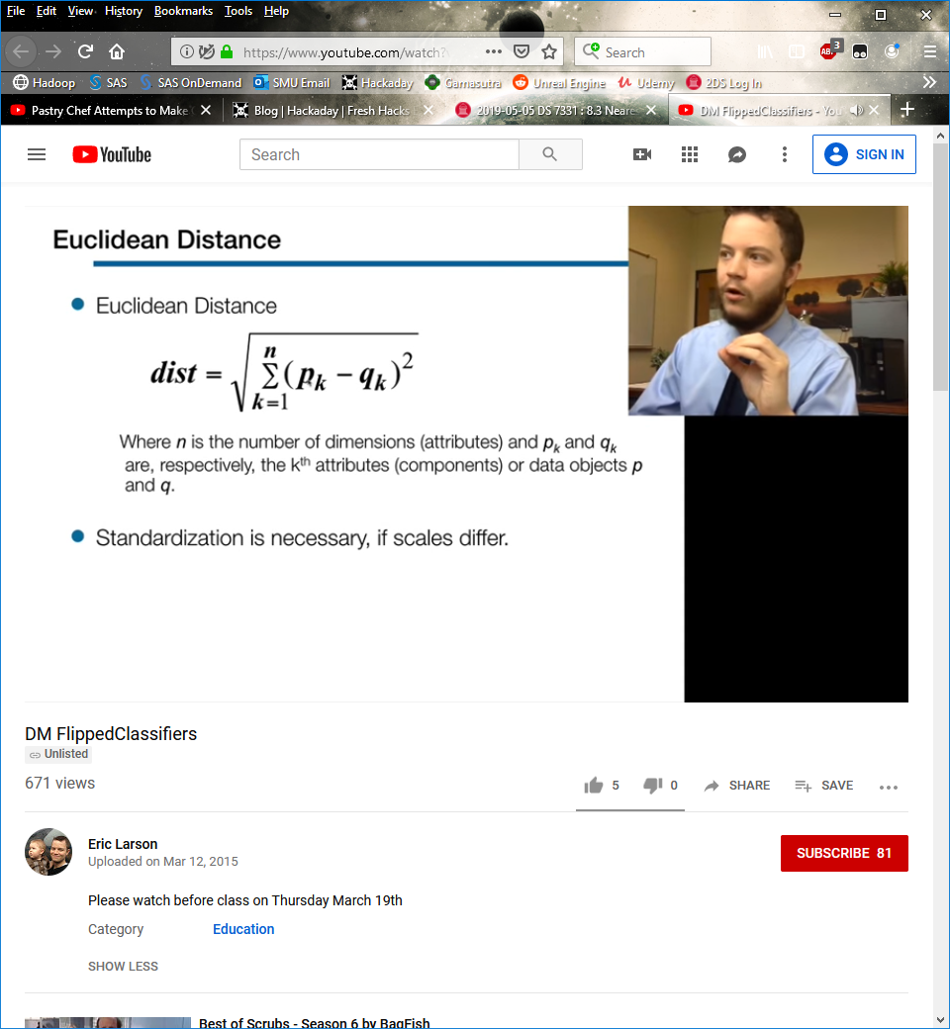

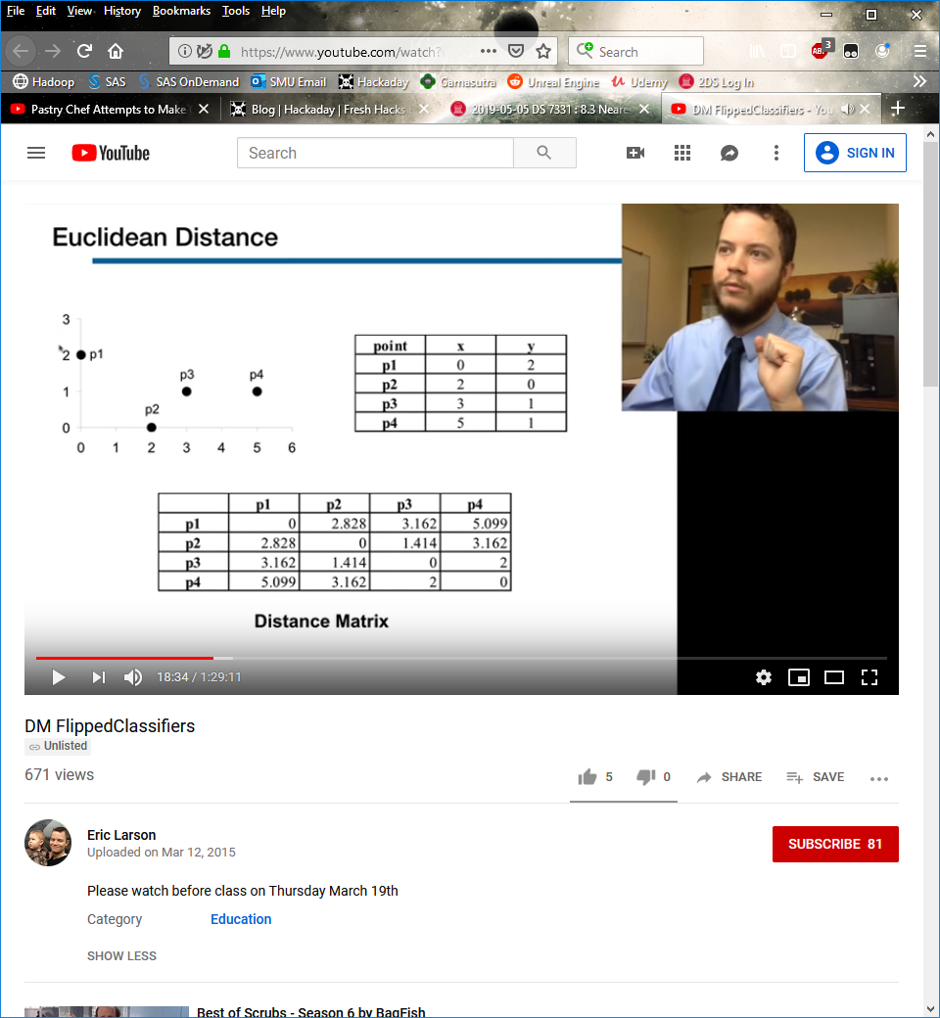

**Minkowski Distance**



**Minkowski Distance: Examples**

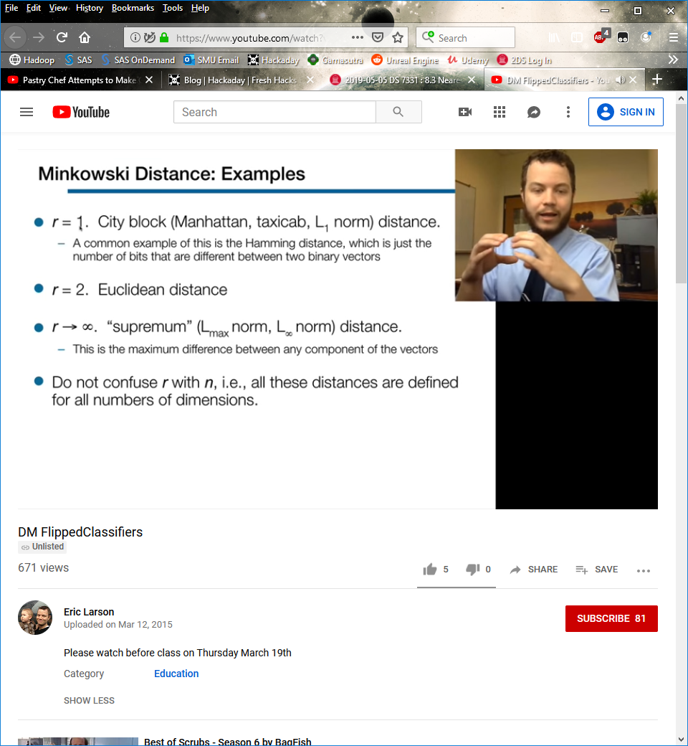

**Minkowski Distance**

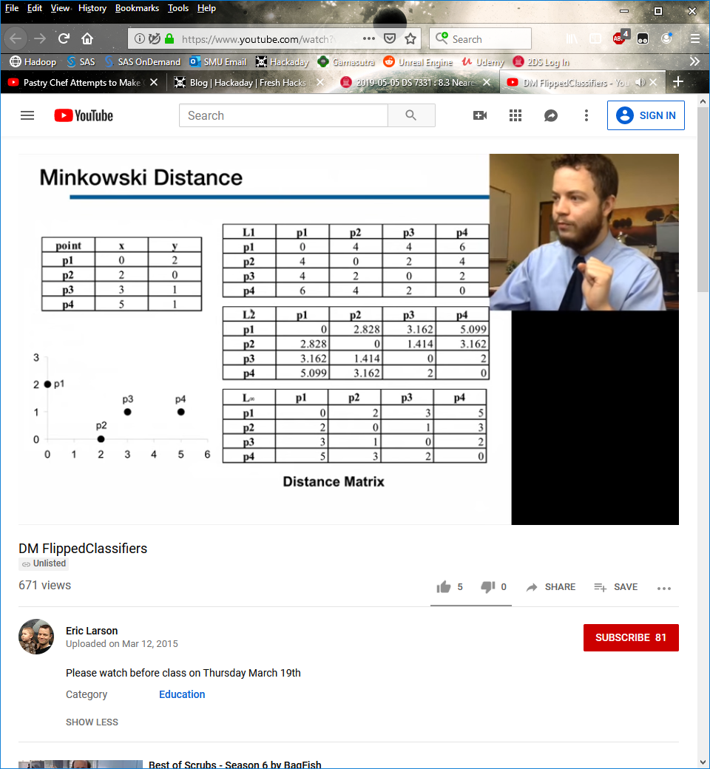

L1 and L2 are pretty close to each other

**Mahalanobis Distance**

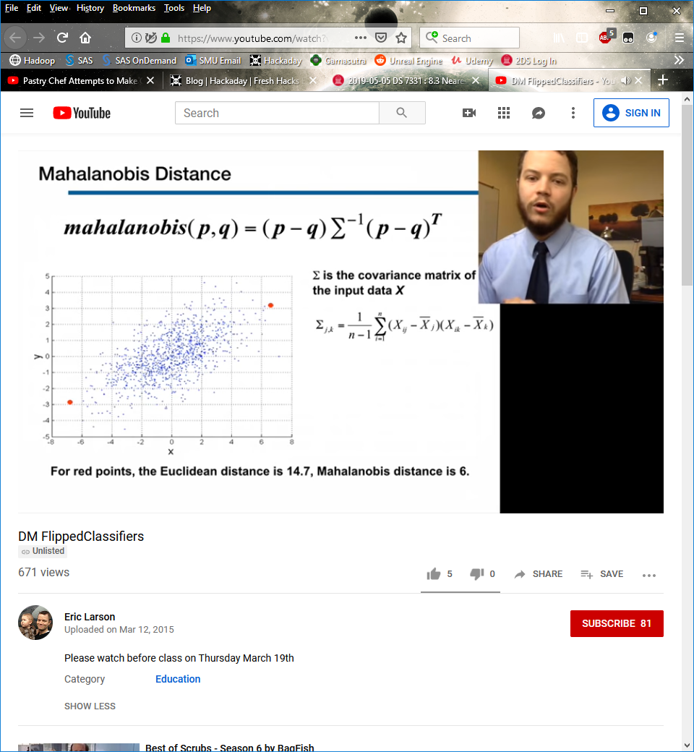

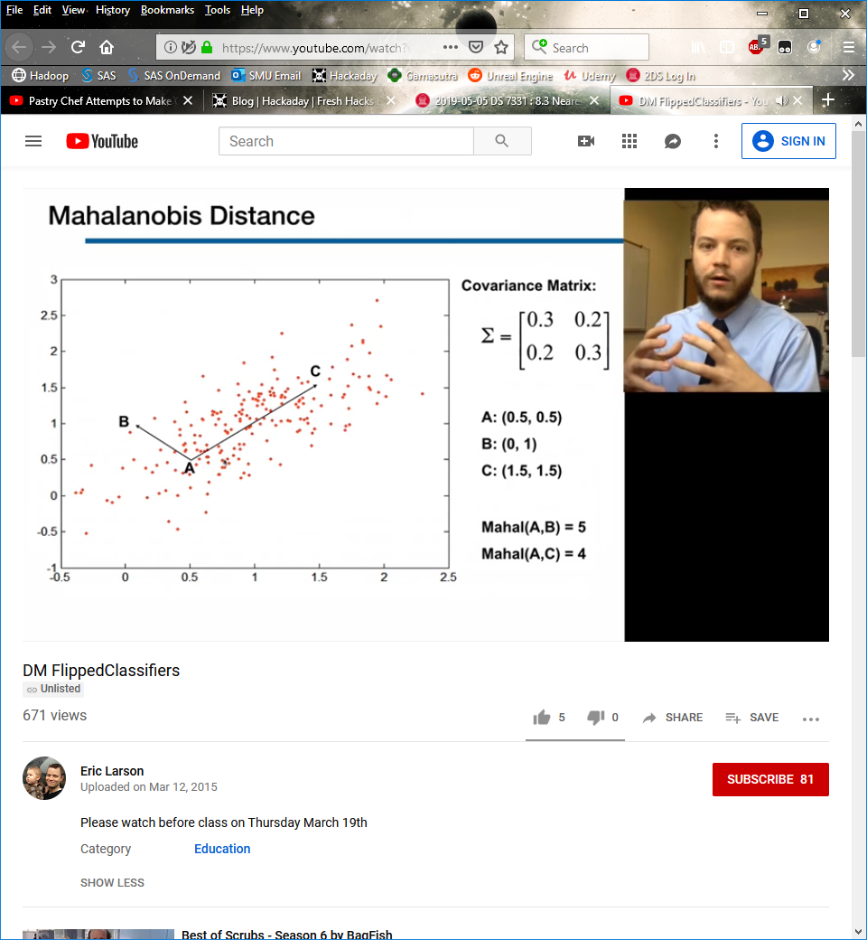

Looks at how the distance varies, and scales the distance accordingly

**Common Properties of a Similarity**

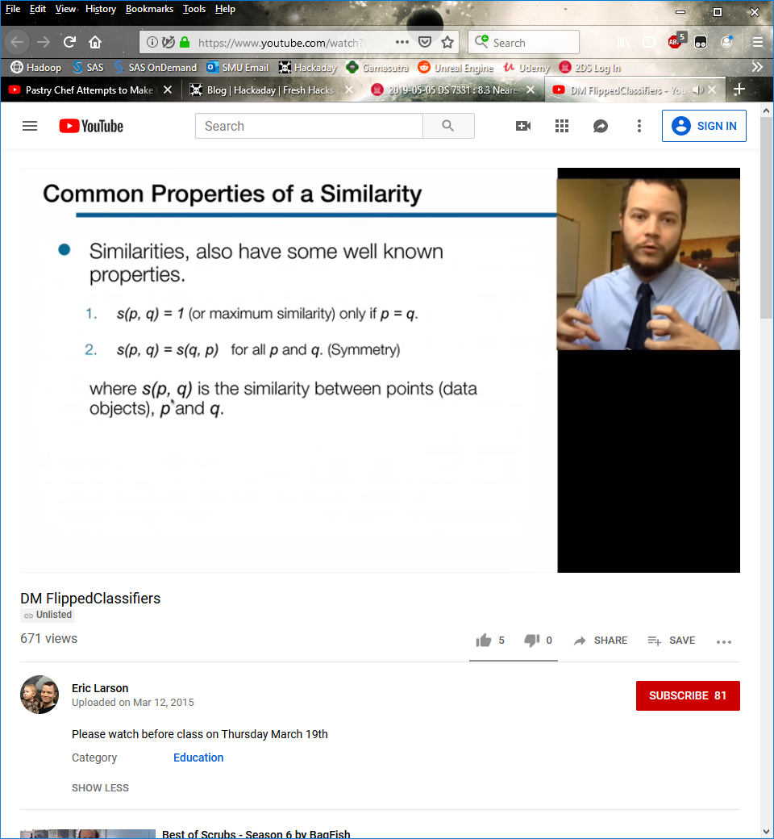

**Similarity Between Binary Vectors**



Jaccard coefficient

**SMC versus Jaccard: Example**



**Cosine Similarity**

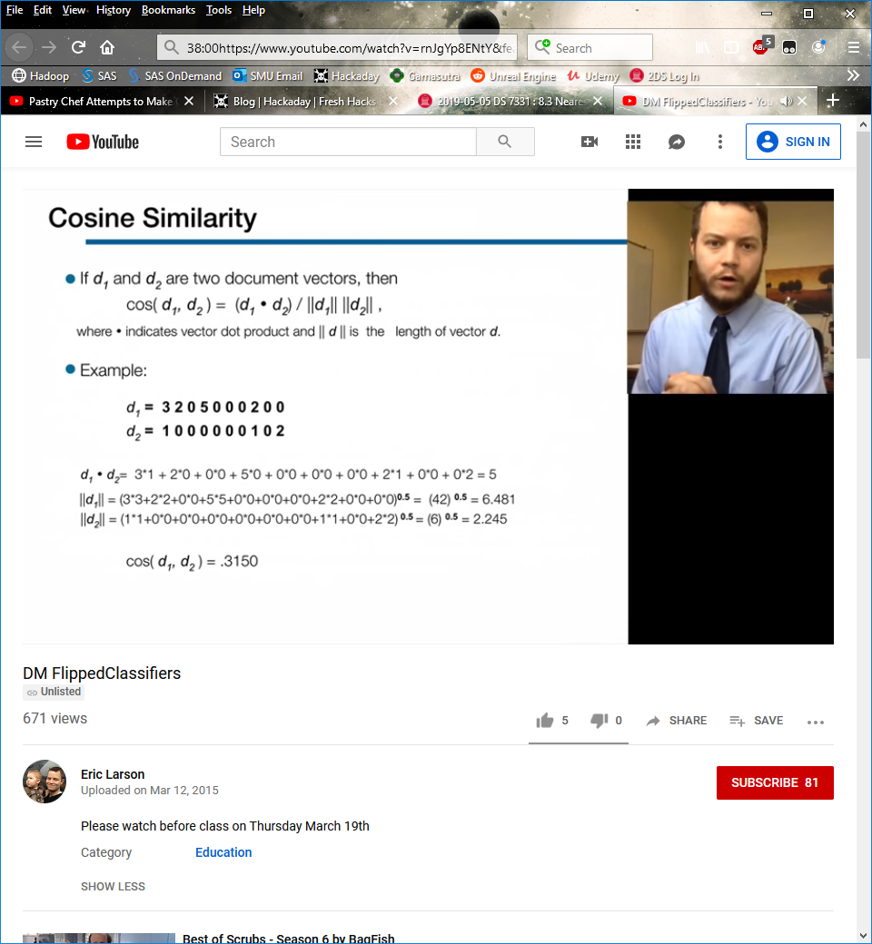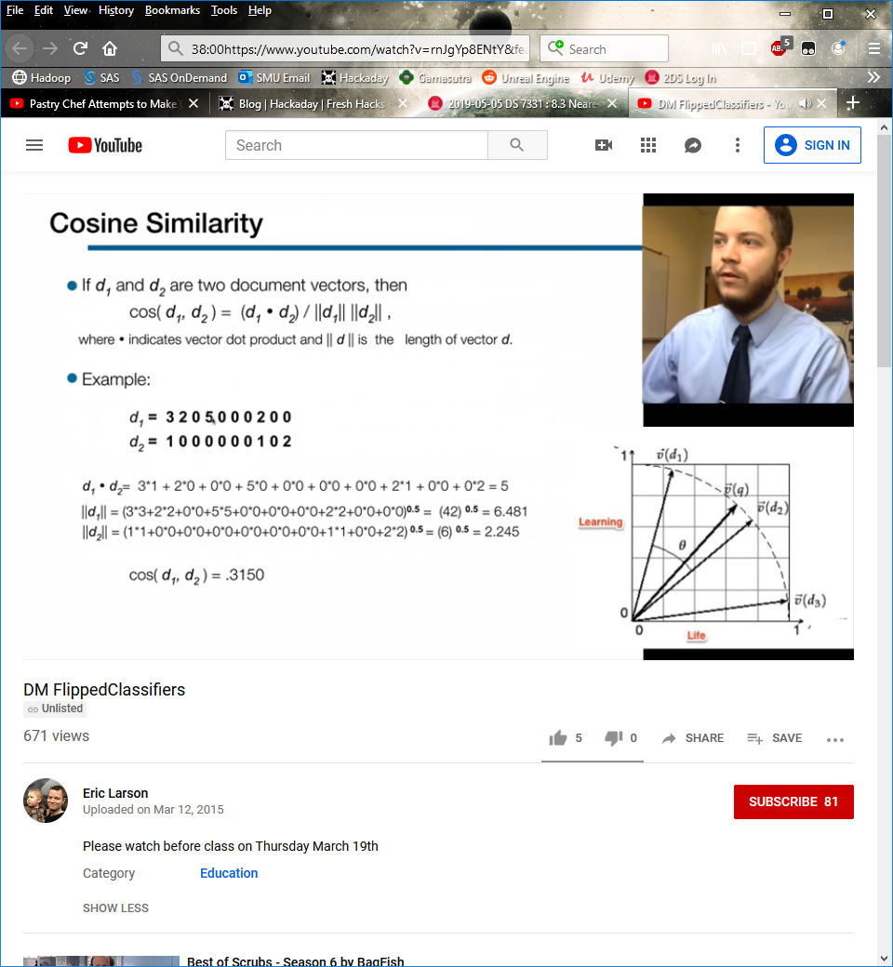

Looks at the angle between them

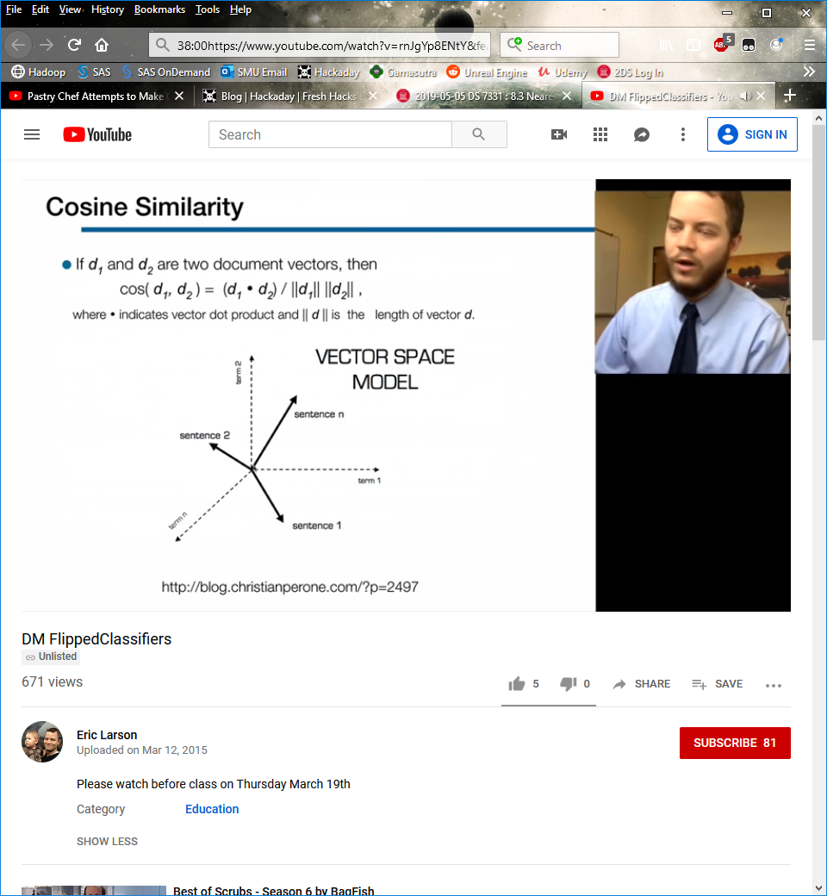

Used a lot when data is sparse, tends to work better than Euclidian distance in that instance

**Correlation**

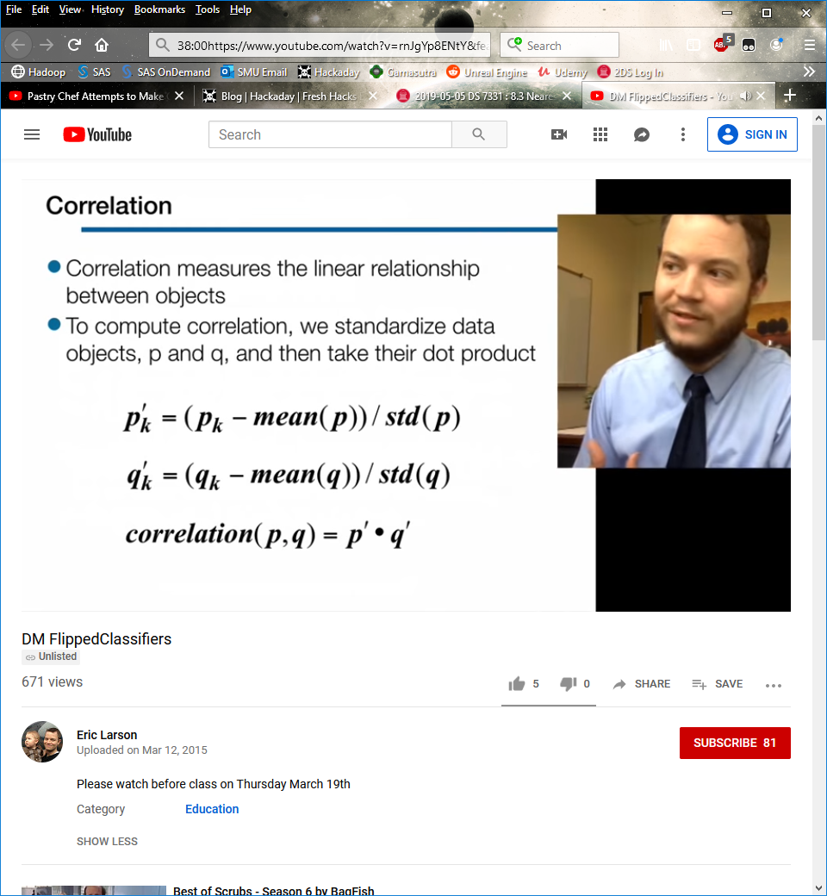

**Visually Evaluating Correlation**

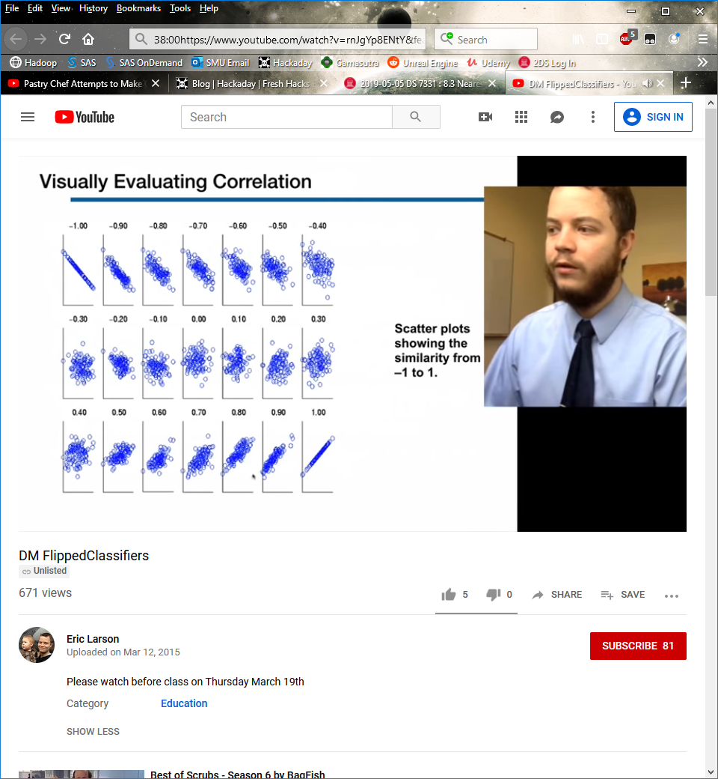

**General Approach for Combining Similarities**

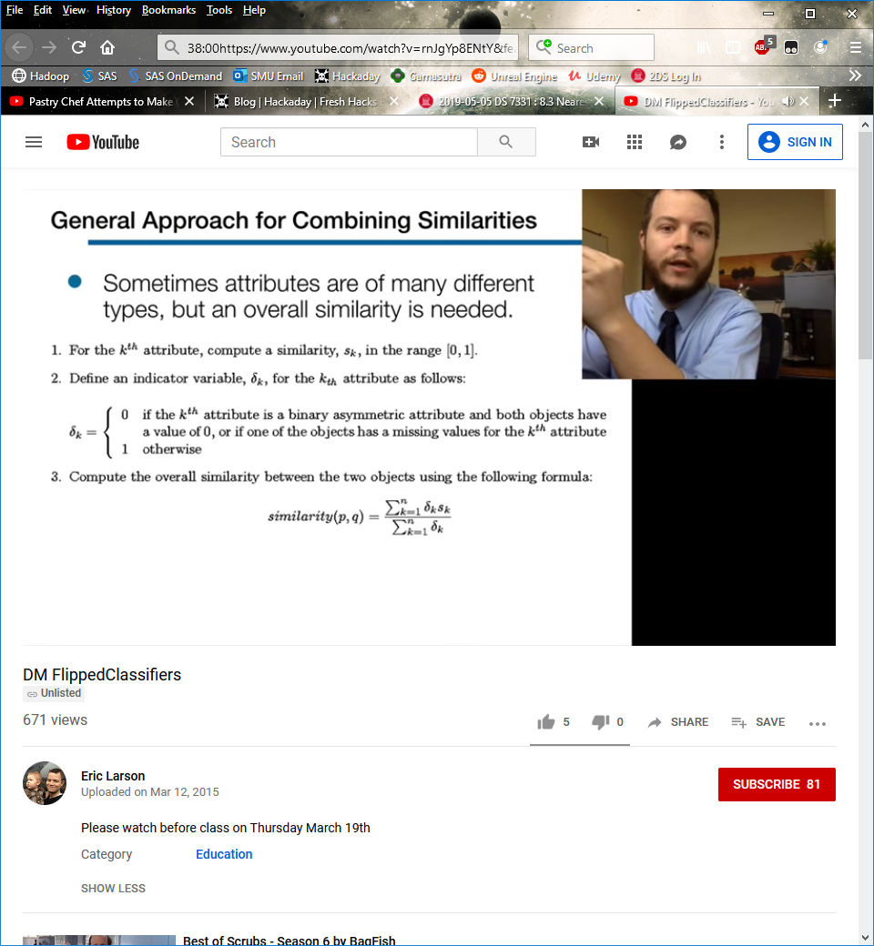

**Using Weights to Combine Similarities**

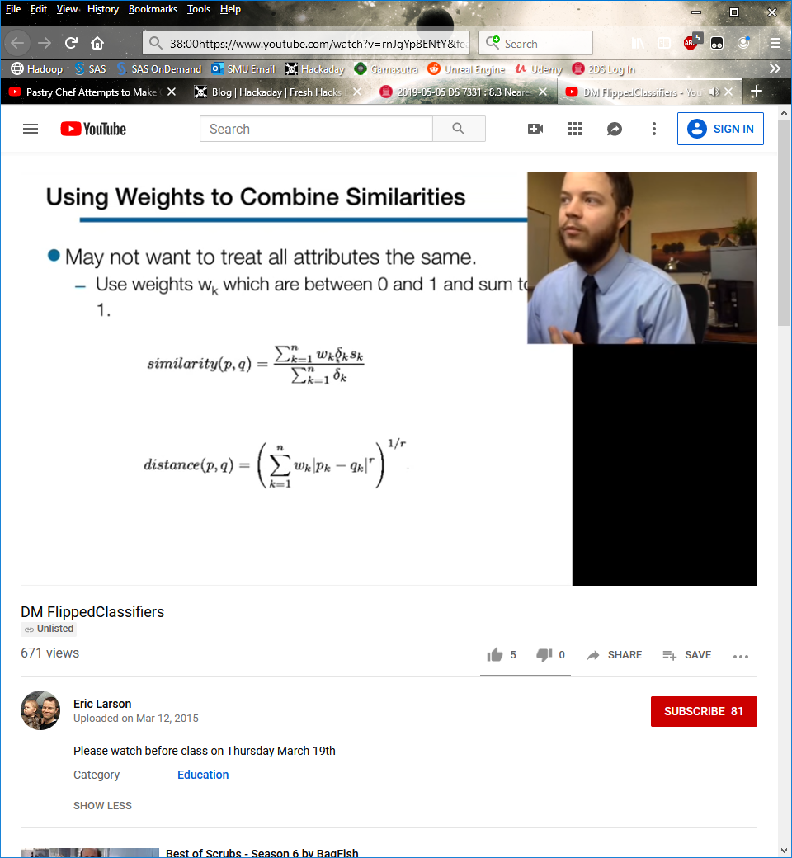

Have to tell algorithm using (domain knowledge) what should be weighted more highly

**END YOUTUBE VIDEO**

**Nominal Attributes (MVDM)**

No concept of order

Distance between two nominal values computed using modified value difference metric (MVDM)

*d*(*V*1, *V*2)

*V*1= Probability of class *i*, given attribute 1

*V*2= Probability of class *i*, given attribute 1

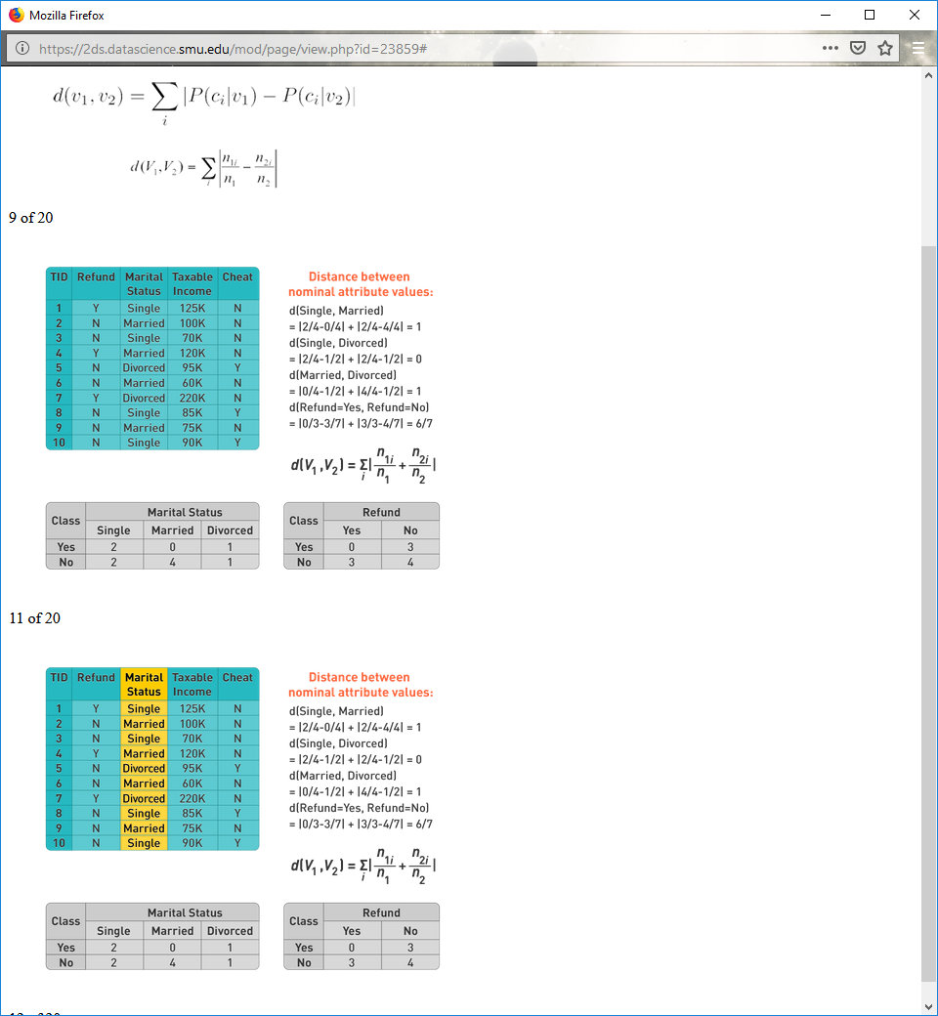







**8.4**

**KNN Regression**

KNN can also be used for regression problems where we want to predict a numeric value.

Use the average y value of the KNNs as the predicted value.

This estimates E(y | x), the average y value at x, which minimizes mean squared error.

**Example: Cardiovascular Disease Risk Factors**

The independent variable x is a patient's waist circumference.

The dependent variable y is a patient's deep abdominal adipose tissue.

Researchers want to predict the amount of deep abdominal adipose tissue from a simple measurement of waist circumference.

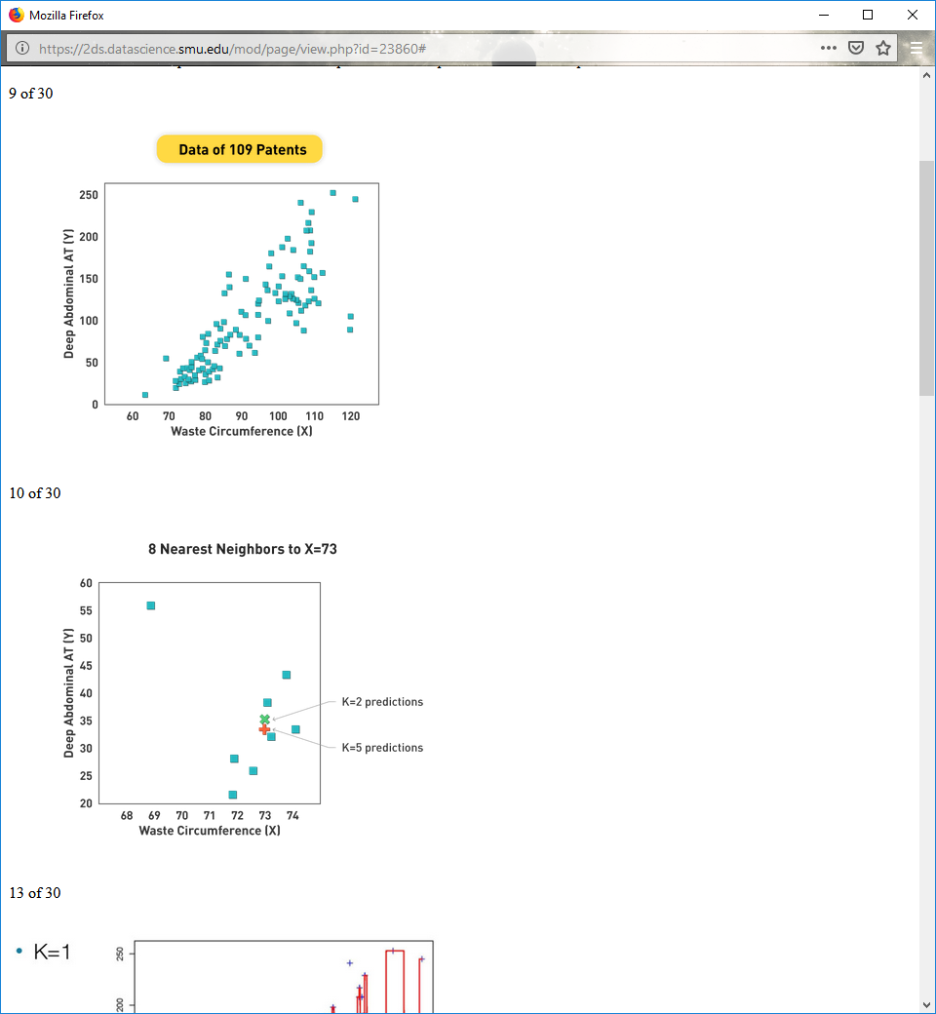 

lol waste instead of waist

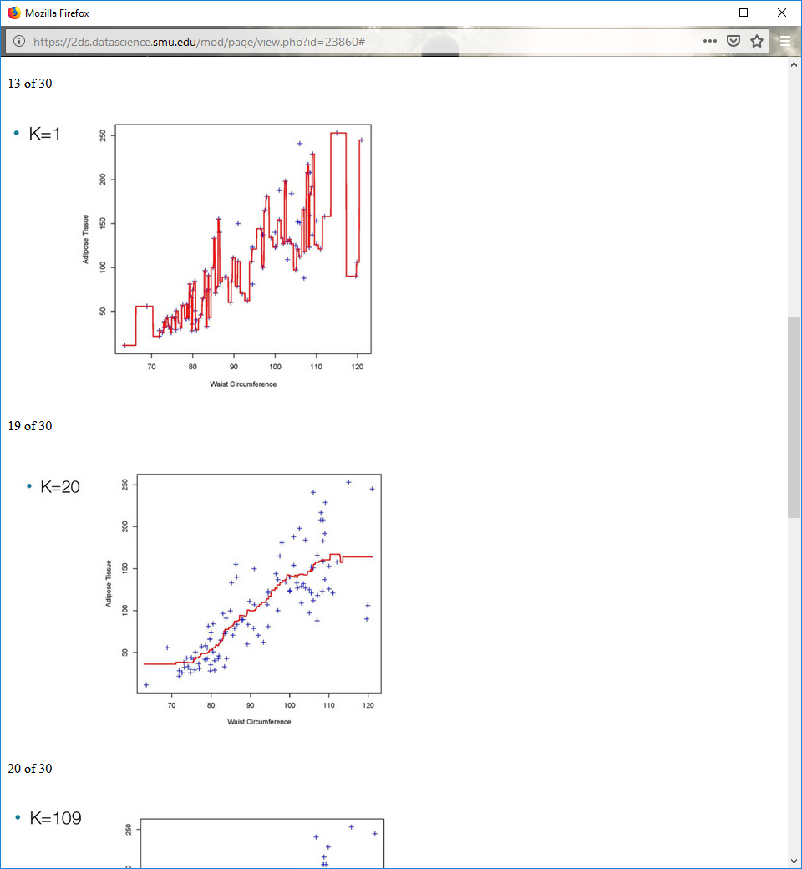

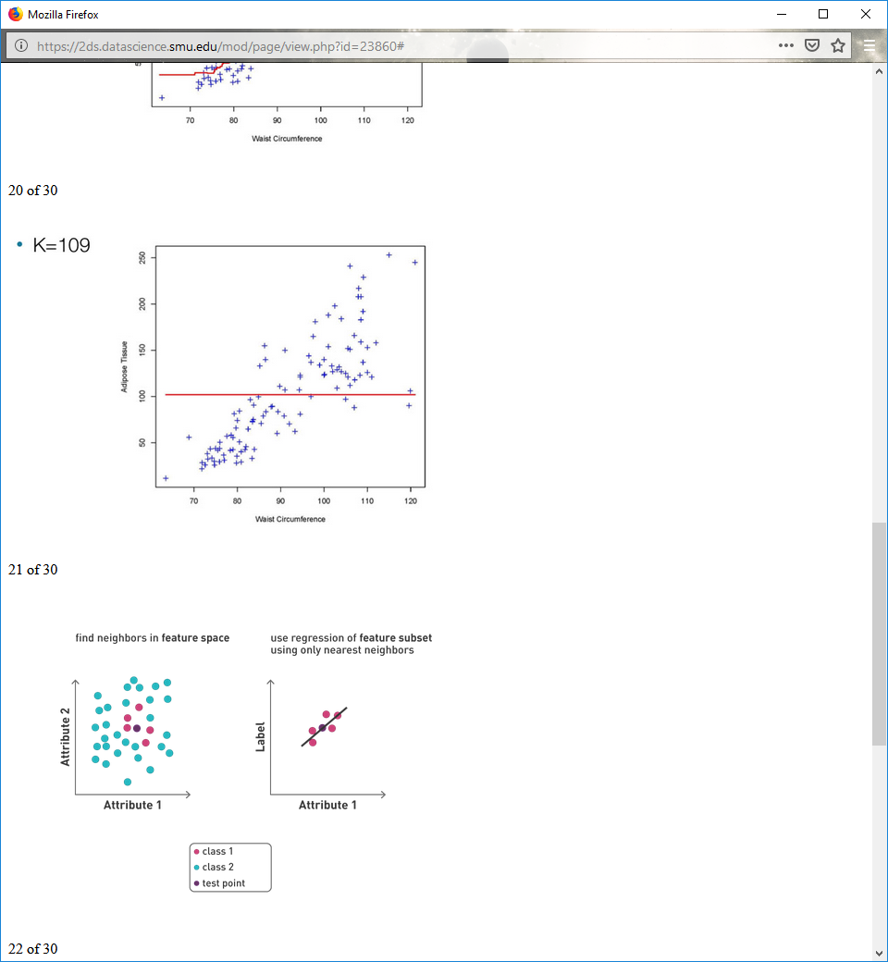

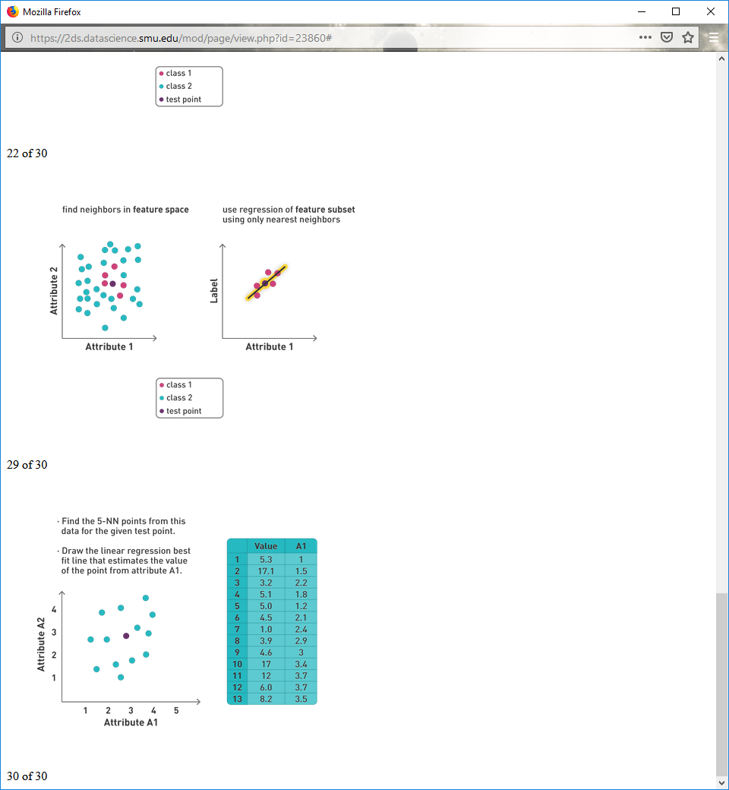

Doing this has some of the lowest bias out of any regression technique



**8.5**

**Big-ish Data: KDTrees for KNN**

A way to make space of KNN more traceable

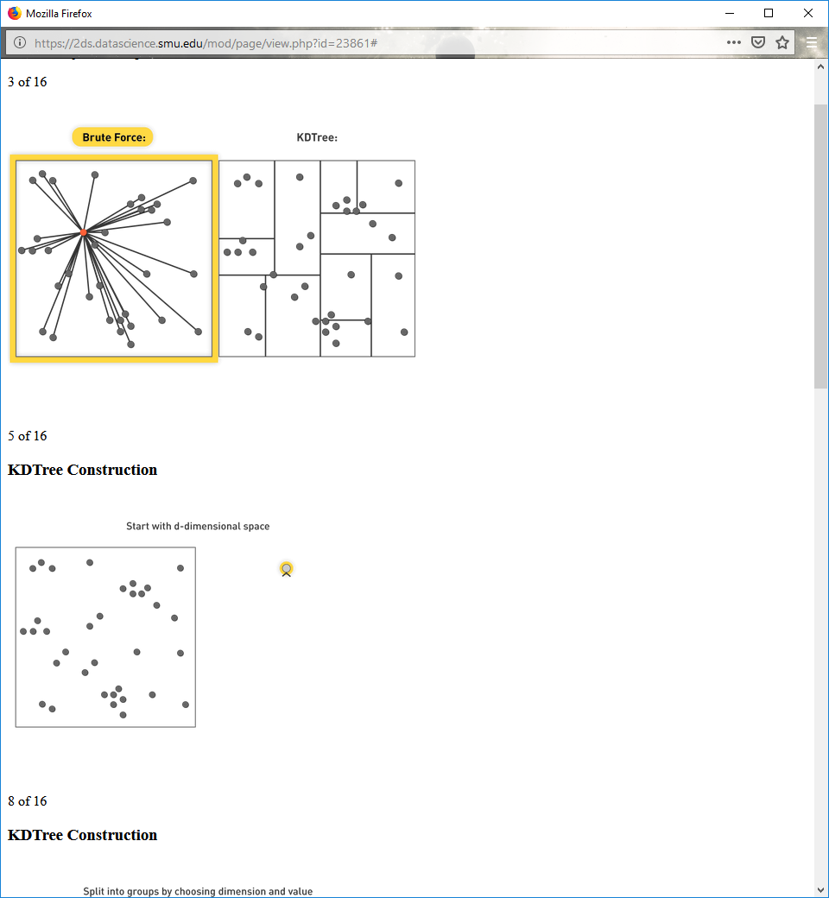

**KDTree Construction**

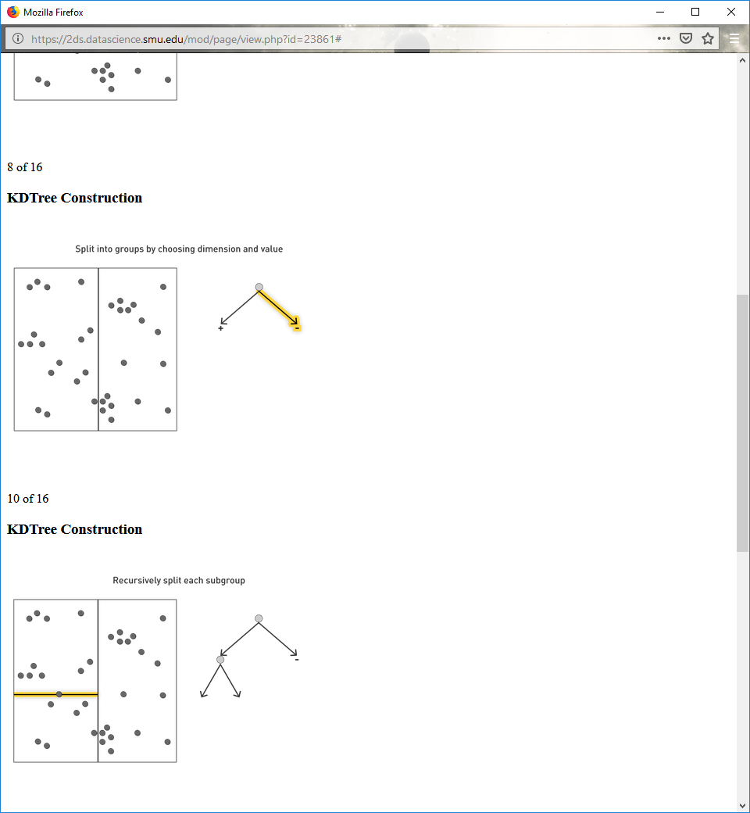

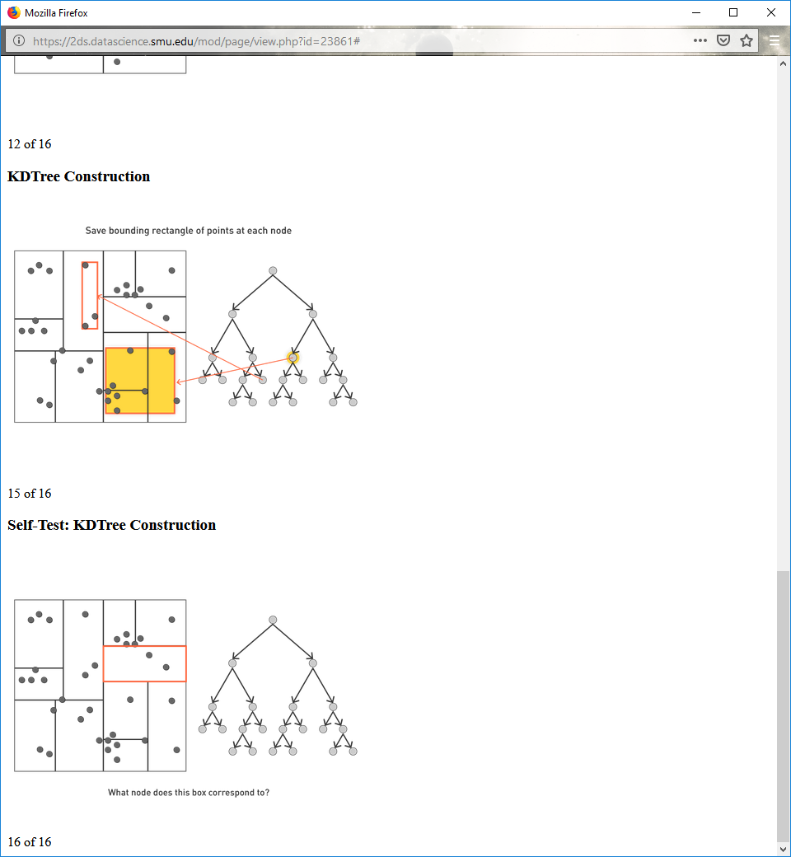

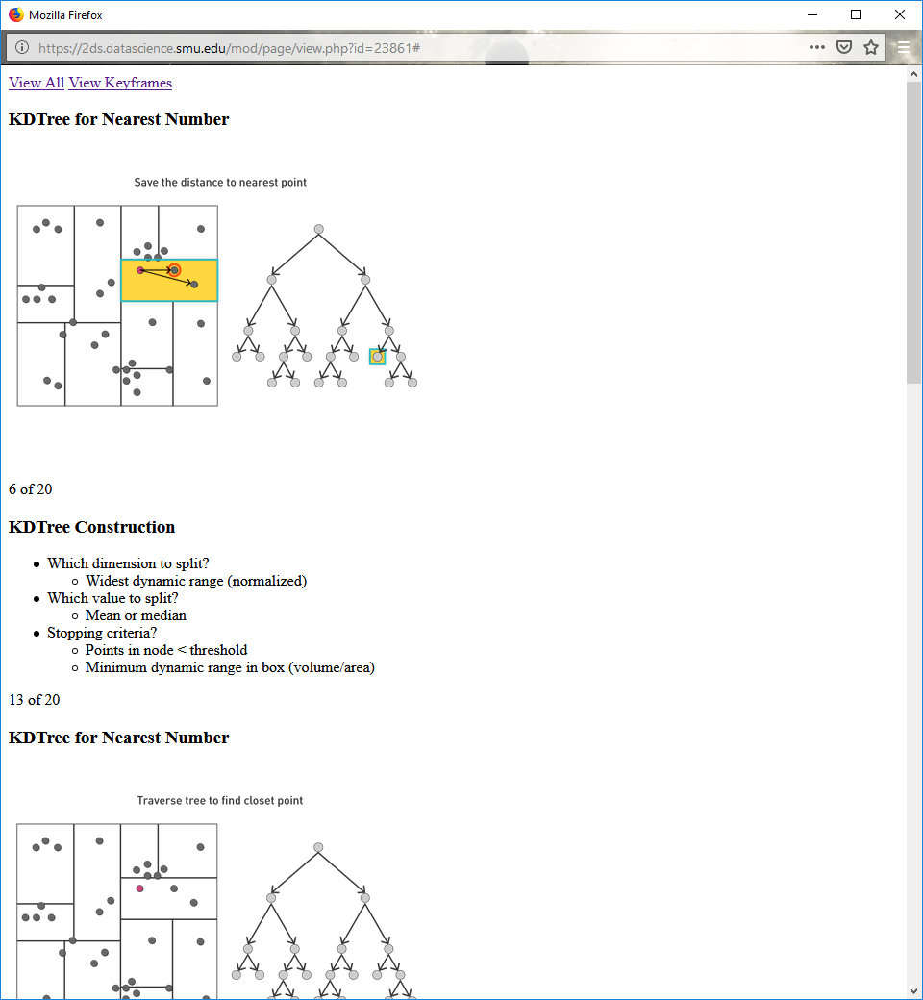

**KDTree Construction**

Which dimension to split?

Widest dynamic range (normalized)

Which value to split?

Mean or median

Stopping criteria?

Points in node < threshold

Minimum dynamic range in box (volume/area)

**KDTree for Nearest Number**

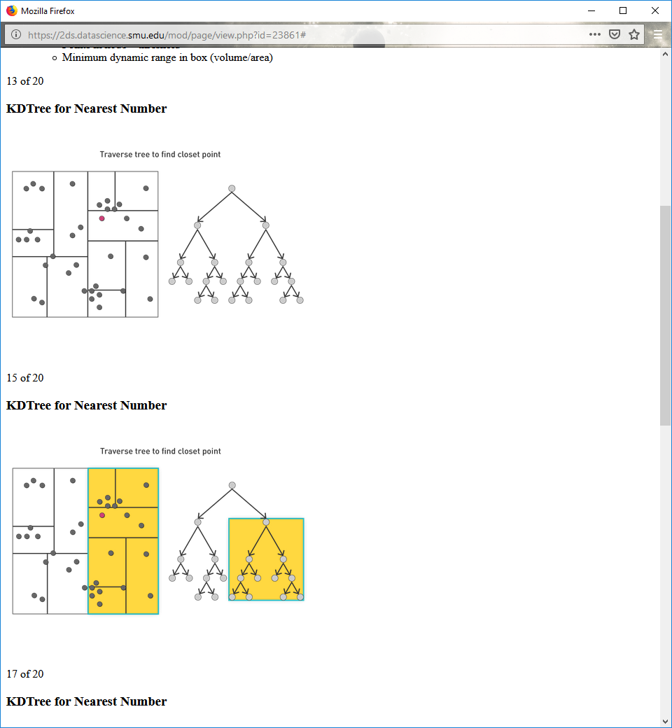

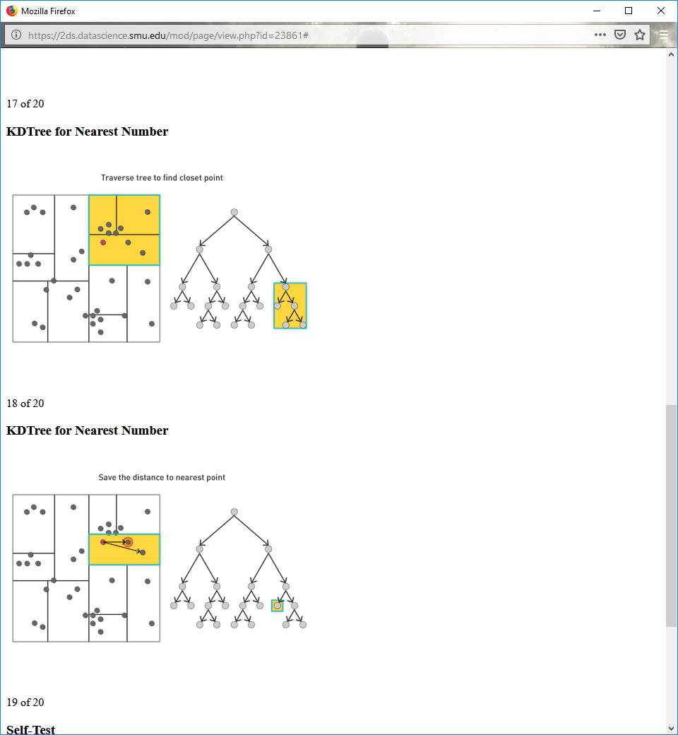

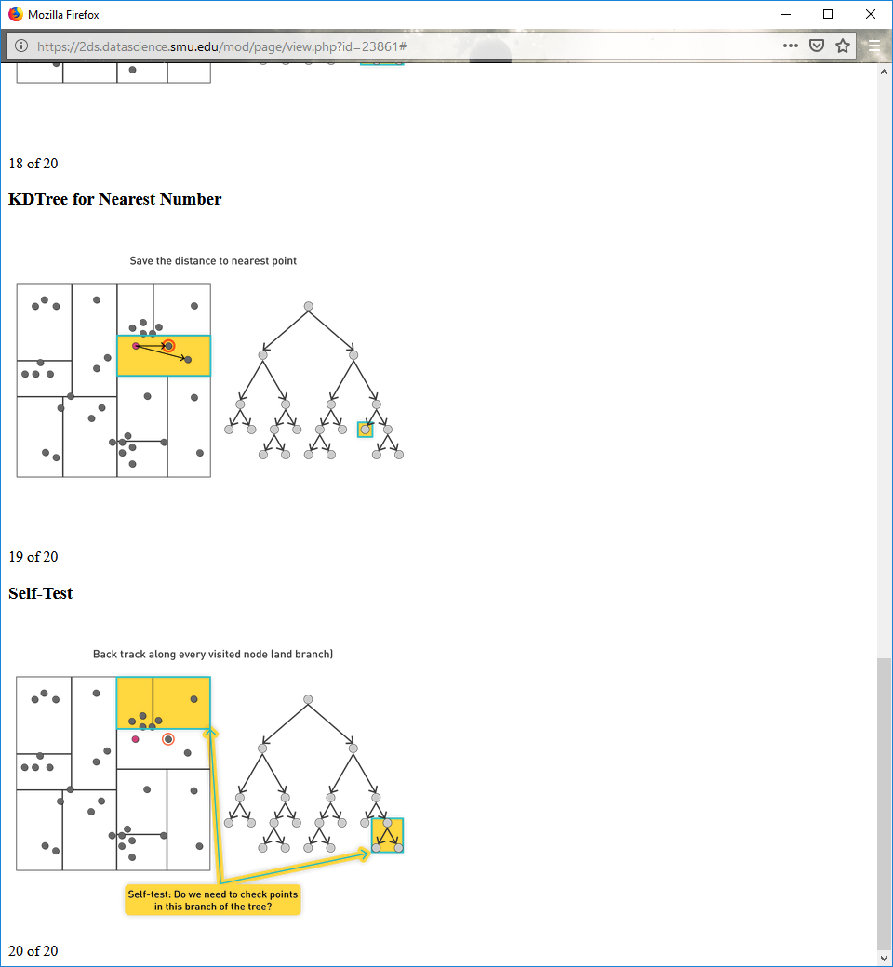

**KDTree for Nearest Neighbor**

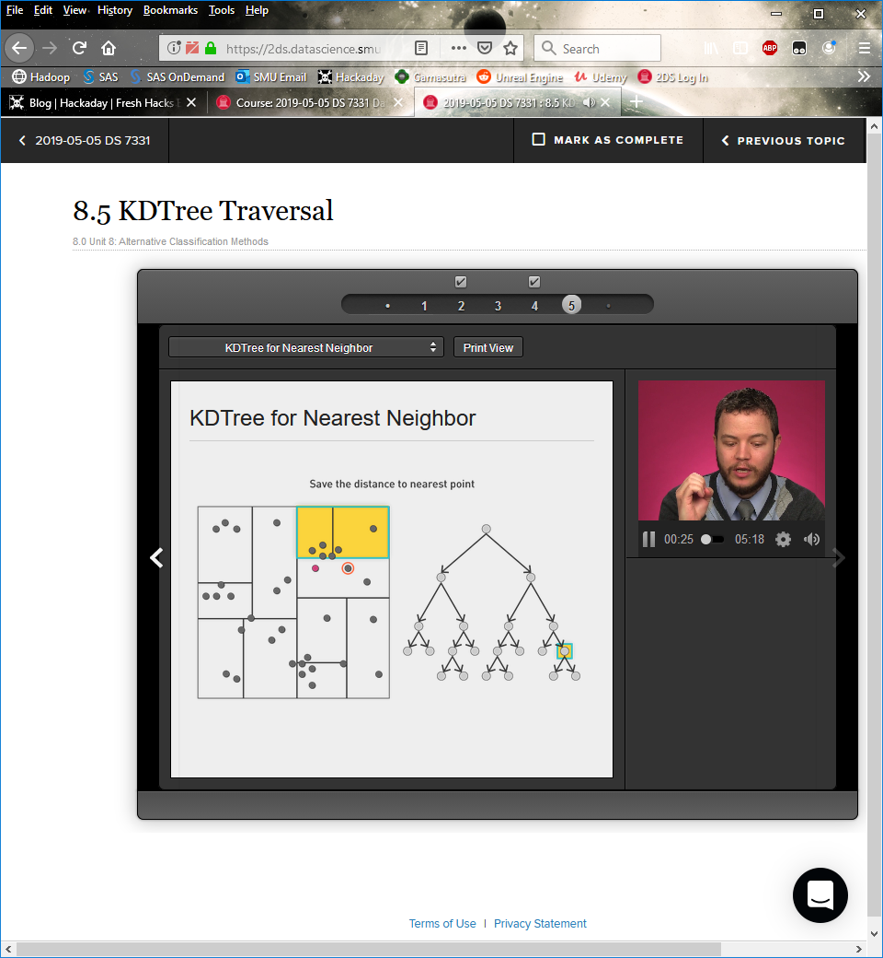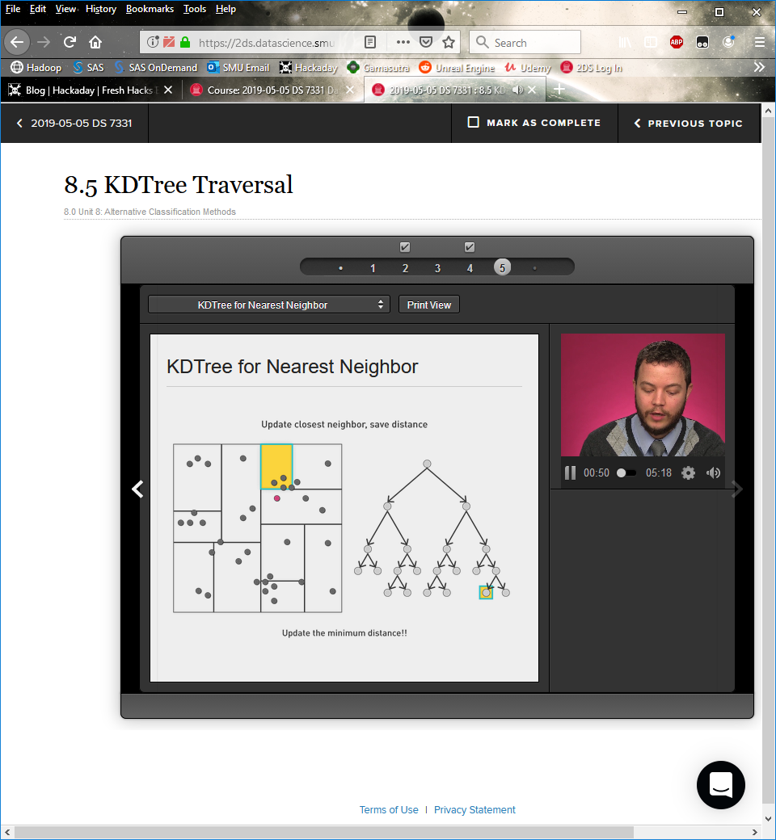

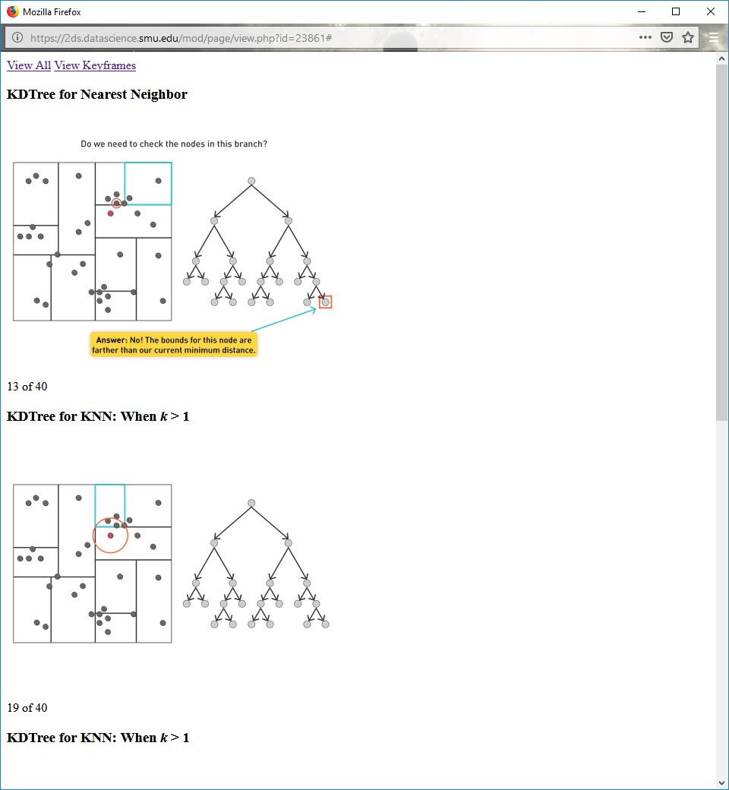

**KDTree for KNN: When k > 1**

 

**Approximate KDTree for KNN**

Exact Algorithm: *r* < distance to bounding box

New Algorithm: *r* < α × distance to bounding box

Suboptimal, but still works well

No one point closer than *r*/α

An approximate method, but this has a complexity better than the KDTree

**KDTree for KNN: Queries**

Query for nearest neighbor, balanced tree

Usual case O(log N)

Worst case O(N)

Query for KNN

Approximate almost always O(k log N)

Worst case O(N log k)

**KNN Summary**

Get dimensions down

Normalize features

Use KDTree to optimize query

Can't use KDTree?

Use ball tree (better but suffers from curse of dimensionality)

Use locality sensitive hashing functions

Choose a different classifier

**8.6**

**Bayes Classifier**

A probabilistic framework for solving classification problems

Conditional probability:



Bayes theorem:



**Self-Test: Example of Bayes Theorem**

A doctor knows that meningitis causes stiff neck 50% of the time.

Prior probability of any patient having meningitis is 1/50,000.

Prior probability of any patient having a stiff neck is 1/20.

If a patient has a stiff neck, what's the probability he/she has meningitis?

**Bayesian Classifiers**

Assumption: each attribute and class label is a random variable

Example: a record with attributes (*A*1, *A*2,..., *An*)

Goal: to predict class *C*

Specifically, finding the value of *C* that maximizes *P*(*C*| *A*1, *A*2,..., *An*)

How to estimate *P*(*C| A*1, *A*2,..., *An*) directly from the data?

From the tax evasion example

*P*(evade=yes| No refund, married, 75K)

*P*(evade=no| No refund, married, 75K)

**Approach to Bayesian Classifiers**

Compute the postierior probability *P*(*C| A*1, *A*2,..., *An*) for all values of C using the Bayes theorem



**Naïve Bayes Classifier**

Assume independence among attributes A1 when class is given

*P*(*A*1, *A*2,..., *An* | *C*j) = *P*(*A*1|*C*j) *P*(*A*2|*C*j)… *P*(*A*n|*C*j)

Naively assume that attributes are independent of one another even if they’re not

Use training data to estimate *P*(*A*i|*C*j) for all *A*i and *C*j

Classify new point to *C*j d if *P*(*C*j) ∏ *P*(*A*i|*C*j) is maximal

Argmaxj *P*(*C*j) ∏ *P*(*A*i|*C*j)

**How do we estimate probabilities form data?**

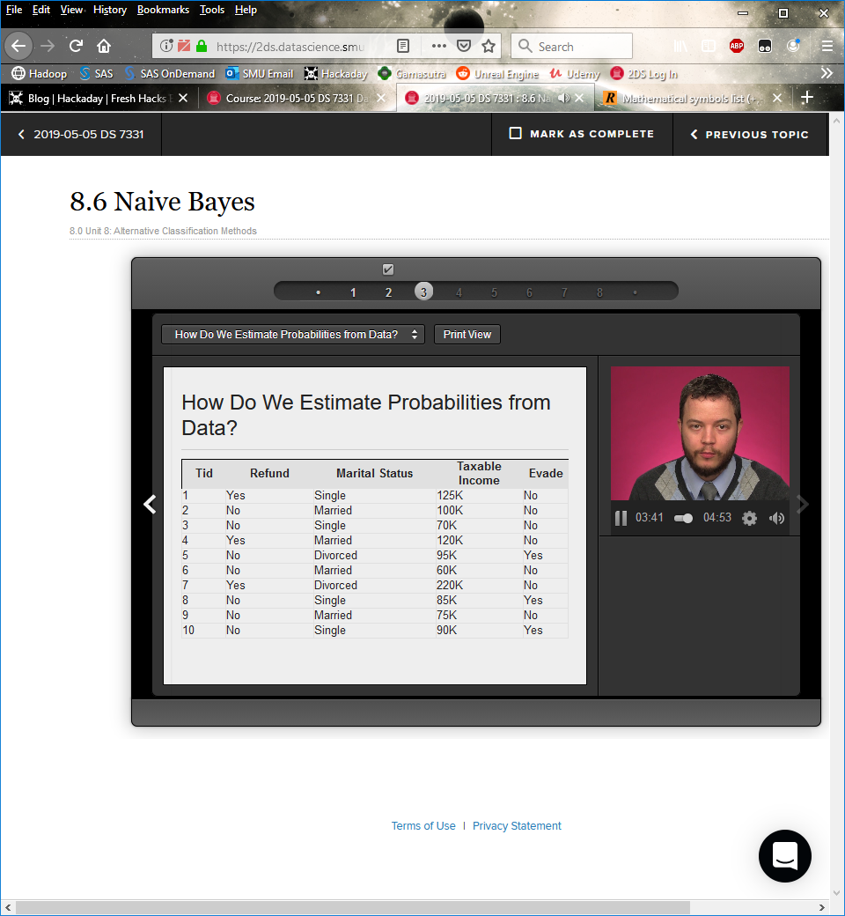

Class P(C) = $\frac{N_{c}}{N}$

E.g., P($N_{0}$) = 7/10, P(Yes) = 3/10

$N_{c}$ = number of occurrences where the class = c

For discrete attributes

*P*(*A*j|*C*k) = |*A*jk|/Nck

Where |*A*jk| is number of instances having attribute *A*j and belongs to class Ck

**Self-Test**

What is the probability that P(Status = Married|No), P(Refund=Yes|Evade=Yes)

**Estimating Probabilities from Data**

For continuous attributes

Discretize the range into bins

Make a two-way split: (*A* < *v*) or (*A* > *v*)

Probability density estimation

Assume underlying distribution is different when Class = Yes, or Class = No

Assume attribute follows a Normal distribution (i.e. Gaussian)

**Normal Distribution**

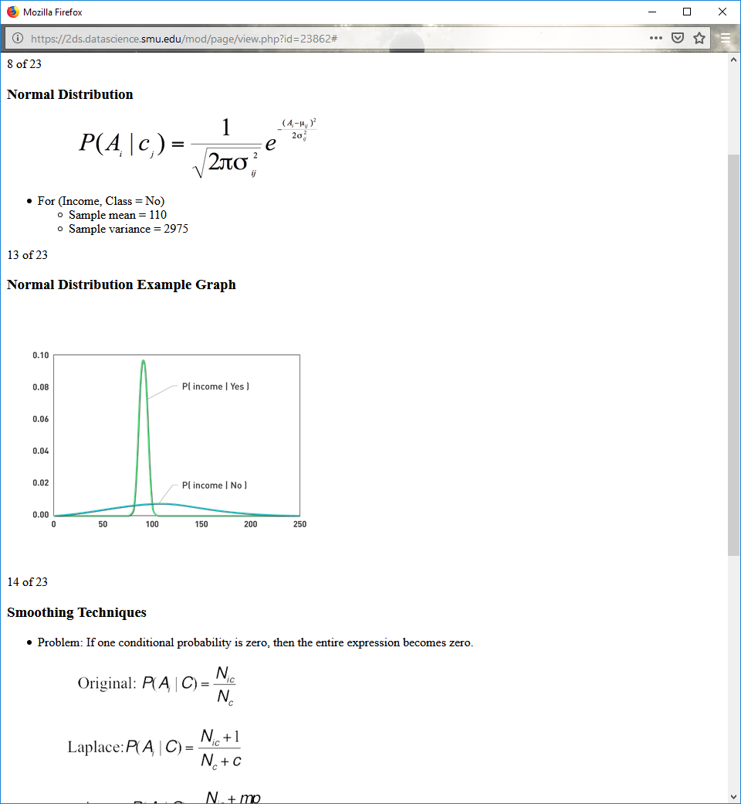

For (Income, Class = No)

Sample mean = 110

Sample variance = 2975

**Normal Distribution Example Graph**



**Smoothing Techniques**

Problem: If one conditional probability is zero, then the entire expression becomes zero.

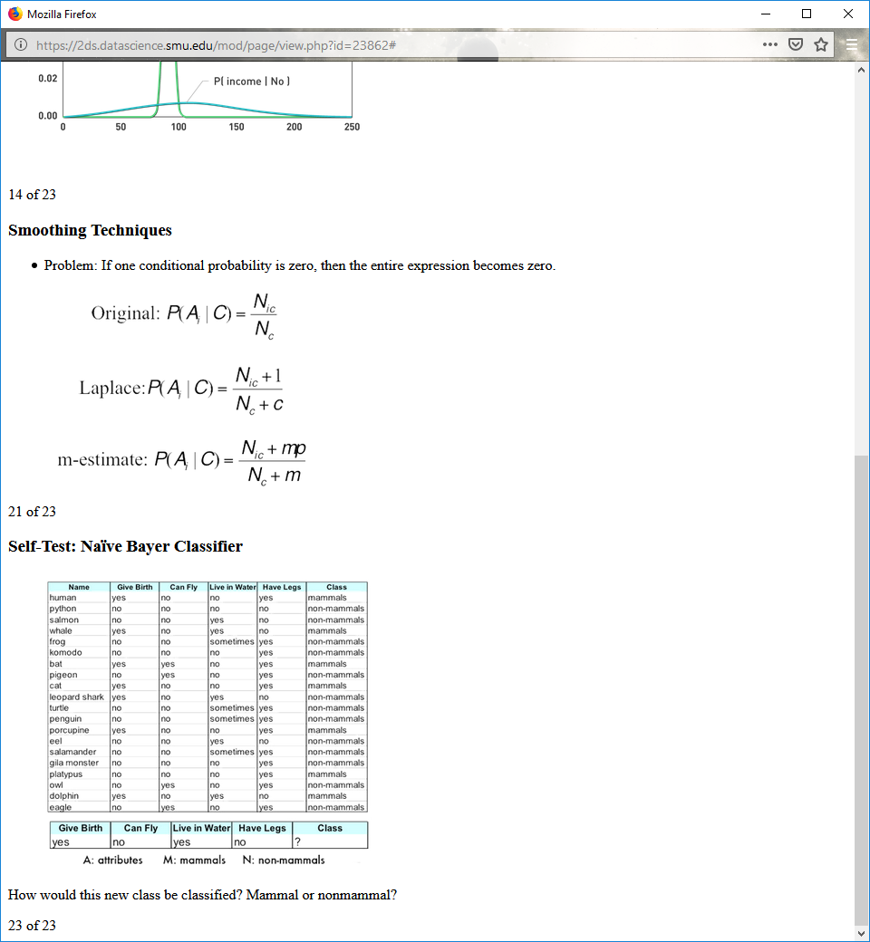

**Self-Test: Naïve Bayer Classifier**



How would this new class be classified? Mammal or nonmammal?

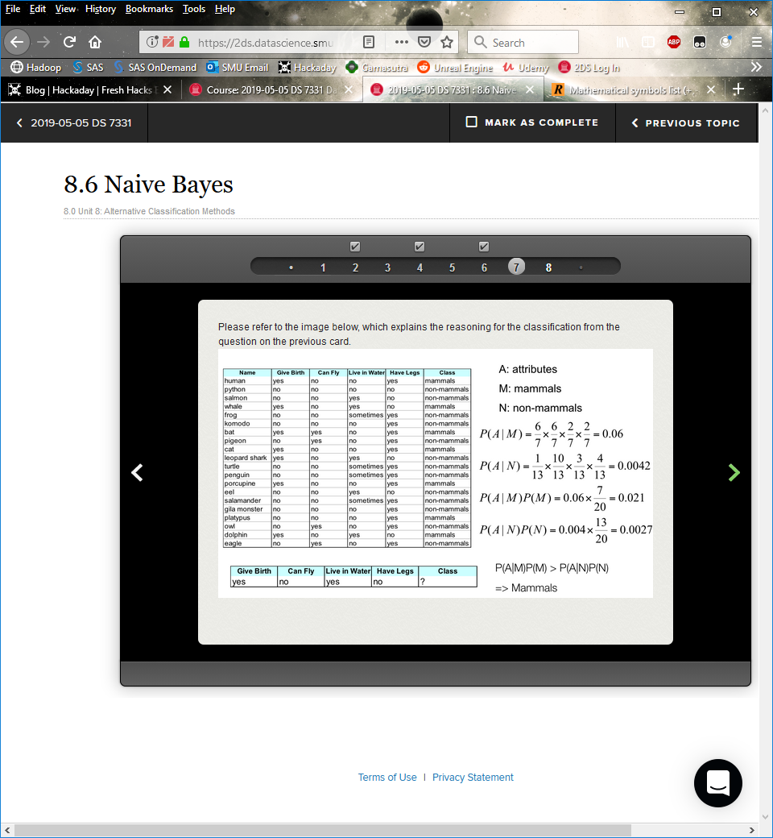

**Naïve Bayes Summary**

Is robust to isolated noise points

Can handle missing values by ignoring instance during probability estimate calculations

Is robust to irrelevant attributes (because they will come back as about 0.5)

Cannot assume independence for some attributes

Other techniques such as Bayesian belief networks (BBN) possible

Training and inference complications (tool kits exist, i.e., graphical models tool kit, gmtk)